Consumer Care Book
HE Table Grill

HD4466

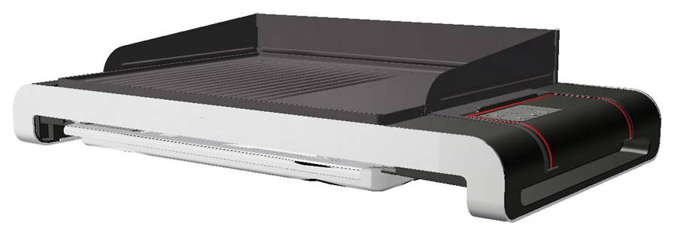
Category: Kitchen Appliances
Author: Ruud Verbeek
Date: 2009/06/05
Version: v2.0
AKB nummer: AKB 32RV-09000011
No. of pages: 16
CMM: Michiel Kerkhaert

(Please place a scan signature)

Date: YEAR/MM/DD

Index

1 Introduction, planning 3
1.1 General Introduction 3
1.2 IPD milestones 4
1.3 Introduction Regions/countries, Quantities, Price 4
1.4 Total predictions of sales (sales in Year / total sales) 4
1.5 Consumer Service Offering (CSO) and repair process 5
1.6 Consumer (CRM) & Loyalty 5
2.1 Range overview 6
2.2 Product specifications 6
2.3 New commercial features 6
2.4 Commercial Accessories 6
3 Architecture and characteristics 7
3.1 Mechanical 7
3.3 Critical spare parts 8
3.4 Consumer replaceable parts (CRP) 8
4 Cost of non quality prediction 9
4.1 Call center cost 9
4.2 CPI (Cost per Intervention) & Expected call center costs 9
4.3 Predicted Field Quality (PFQ) or Field Call Rate (FCR) 9
4.4 ConQ (Cost of non Quality) 10
4.5 Charge back agreement 11
4.6 Initial Stocking confirmation 11
4.7 Fast feedback program 12
5 Consumer care package planning 13
5.1 Consumer care package 13
5.2 Special phone number 14
5.3 FAQ (Frequently Asked Questions) 14

Attachment 1: Explanation abbreviations 15

1 Introduction, planning

1.1 General Introduction

This Grill is the High End (HE) Table grill from Philips table grill family,

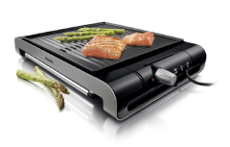 HD4417, Short rip plates
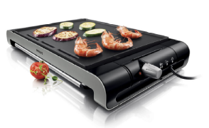 HD4418, long, smooth plates
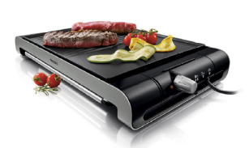 HD4419 long half smooth / half rip plates

The supplier of the table grills is Simatelex. In the information below you will find general information about the HE table grill.

Discover fuller flavours
- High temperature grill plate seals in all the flavour
- Extra thick grill plate stays hot, even with frozen food
- Electronic temperature control ensures perfect results
- High power 2300W for warming up and constant heat
- Free recipe booklet to inspire you with tasty recipes

Only a little effort
- Dishwasher-safe parts make cleaning easy
- Non-stick surface prevents food particles from sticking
- Easy to store upright; tidy storage of cord and tray
- Digital timer with ready signal and auto shut off
- Spatula and tongs in one to remove food from grilling plate

Smart features
- Excess grease is drained to removable tray
- Partly ribbed and partly smooth plate for various dishes
- Splatter guard to keep your surface clean

1.2 IPD milestones


IR
AA
PPC
PV
CR
PE
VPD
IR
PC
CC
Project Plan Committed PPC: wk 917
Send Prototype wk 928
Product Validated PV: wk 932
Industrial Release IR: wk 935
Commercial Release CR: wk 937

1.3 Introduction Regions/countries, Quantities, Price

Type number | Region  Stroke version | First shipment | Total  Planned quantity | FSP | IIP (Invoice price) | net – net price | Going  price
HD4466 (2009) | Europe | Wk 936 | k 44 | € 35.25 | € 56.- | 80,- | € 130,-
* IIP = +/- 73% Net-Net price

Quantities per countries
 | 2009 | 2010
Italy | 2 | 4
France | 3 | 5
Ib | 2 | 3
Gr | 1 | 1
Ben | 2 | 3
CEE | 3 | 5
Poland | 1 | 1
Nordics | 1 | 1
DACH | 2 | 4
 | 17 K | 27 K

1.4 Total predictions of sales (sales in Year / total sales)

2009 = 17 K
2010 = 27 K

1.5 Consumer Service Offering (CSO) and repair process

Region | CSO  Front end | CSO  Back end | Repair process
Europe | Call center FAQ  Web support FAQ  DFU / User manual  Leaflet | Repair | Module swap

All service parts are Consumer replaceable parts

1.6 Consumer (CRM) & Loyalty

n.a
2 Technical specifications

2.1 Range overview

HD4466 HE Table Grill

2.2 Product specifications

Voltage: 230V
Power consumption: 2300W
Frequency: 50-60Hz
Standby power 0.5W

2.3 New commercial features

Digital temp setting and timer
Splatter guards
Electronic temperature control
1 heat zone

2.4 Commercial Accessories
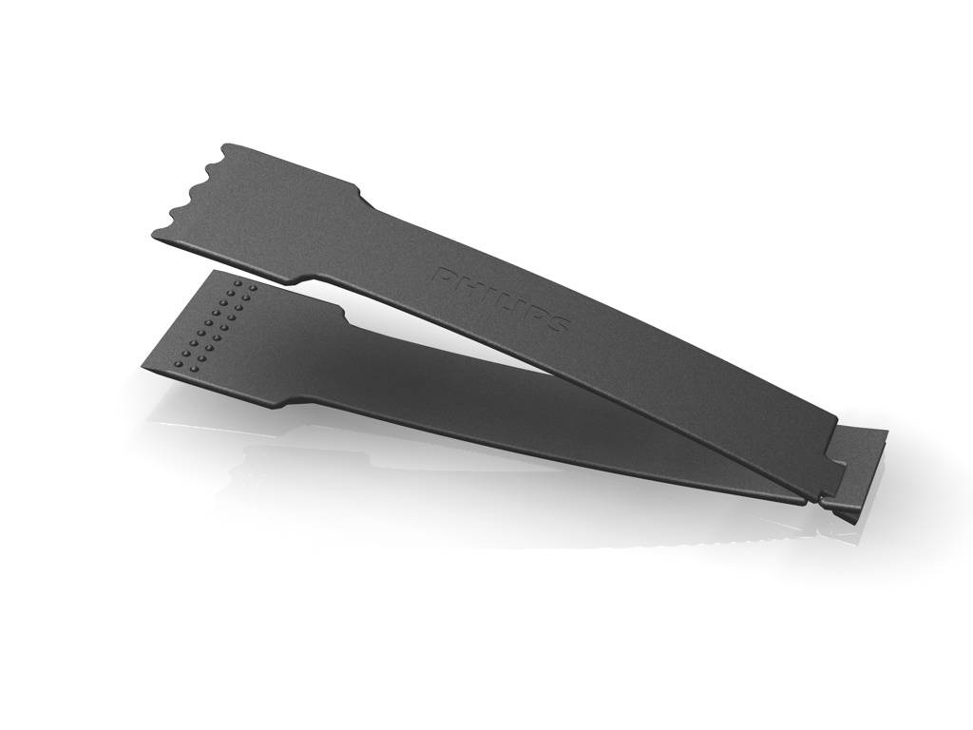
Spatula

3 Architecture and characteristics

3.1 Mechanical
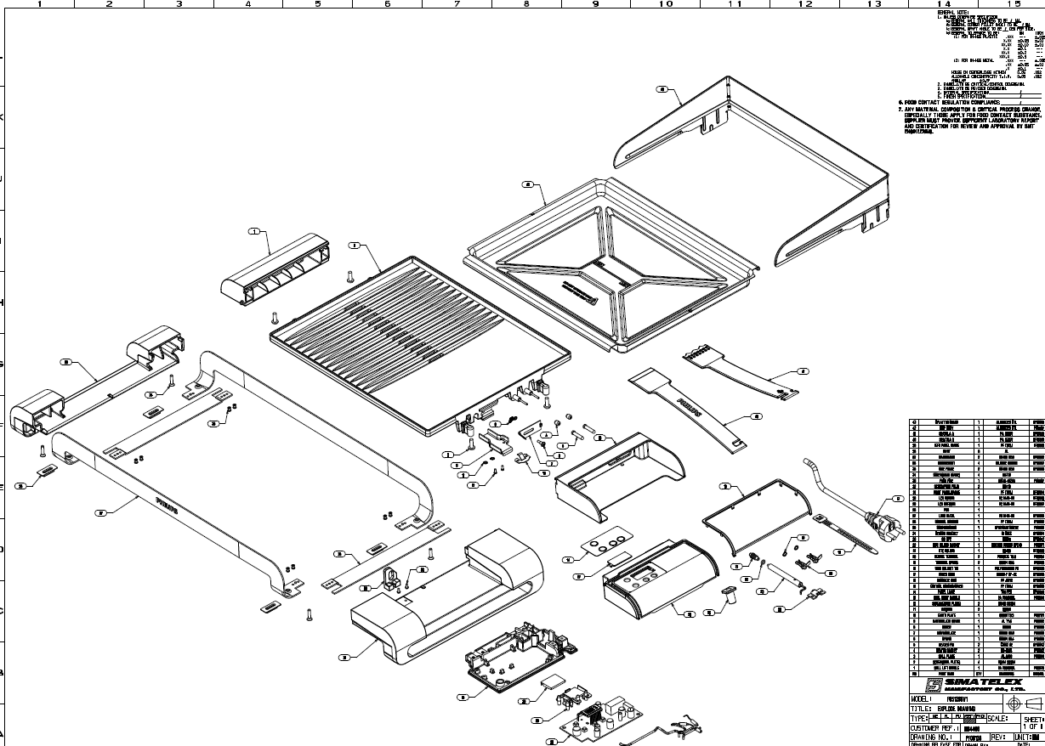

3.2 Electrical circuit

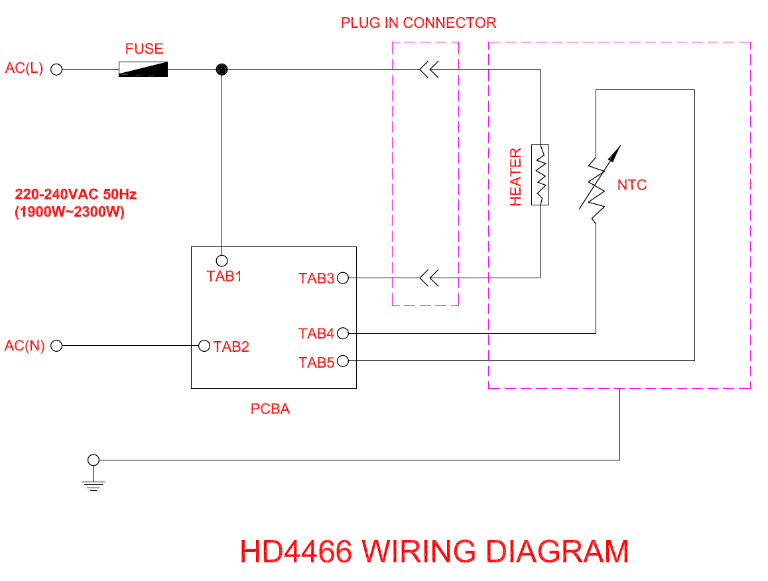

3.3 Critical spare parts

All CRP are critical spare parts)

3.4 Consumer replaceable parts (CRP)

- Heating plate
- Power pin / digital timer (thermostat assy)
- Splatter guards
- Spatula
- Drip tray
- Frame assy

4 Cost of non quality prediction

4.1 Call center cost

(Cost per call = average time * cost per minute)
Region | Type Number | Amount of calls | Total Sales | ACR % | Average call time | Price per minute | Price per call
Europe | HD4419 | 28 | 2561 | 1.09% | 6.2 | € 1.- | € 6.20

- ACR = Amount of calls / total sales
- I use the HD4419 as reference,
- period = Jan 2009 till Mach 2009

4.2 CPI (Cost per Intervention) & Expected call center costs

* See 4.4 ConQ for the CPI

4.3 Predicted Field Quality (PFQ) or Field Call Rate (FCR)

Expected FCR = 1.7%

* Sources = Andes Lui / Kanry Cheung (Project Leader)
* Overview crex, see attachment 2.

4.4 ConQ (Cost of non Quality)

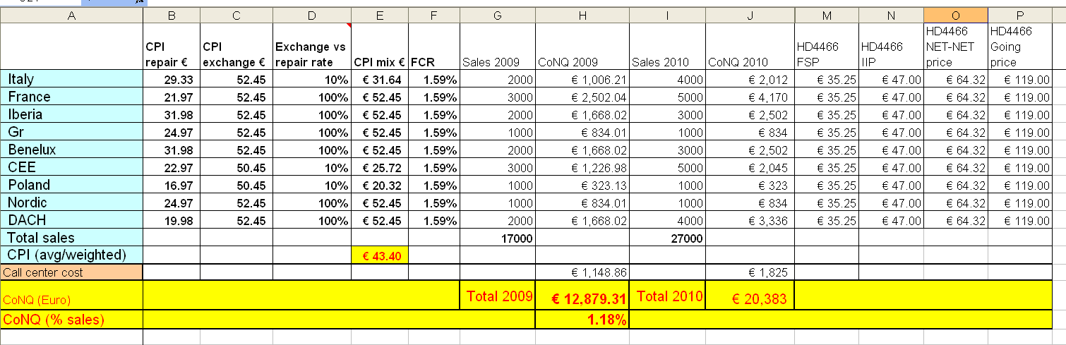

Total Cost of non Quality
2009 = 13.000,- Euro
2010 = 20.000,- Euro

4.5 Charge back agreement

The claim compensation is based on epidemic failure or excess the rate specify in Quality Contract (from Quality team and individual Quality contract will be defined for each model), our quality team will support us to define failure in connection with or arise from supplier’s failure, then we will discuss and settle with supplier based on quality judgment & case by case.

The charge back agreement is not arrange yet between Philips and Simatelex

* Source; Irene Yeung

4.6 Initial Stocking confirmation
n.a

4.7 Fast feedback program

Feedback | regions | Quantity | cost | Yes / No
Repair via initial workshop? | Europe, |  | € | yes/no
Call center feedback | Europe, | 50 | € 100,- | yes/no
Web feedback | Europe, | 50 | € 100,- | yes/no
Rapid exchange | Europe, | 100 | € 5000,- | yes/no
 |  |  | €

Total fast feedback cost | € 5200,-

- To transport 1 appliance for analyze = € 50,- (Estimate)

5 Consumer care package planning

5.1 Consumer care package

 |  | Europe | Accountable
In-box
 | User Manual | W935 | ARC
 | Quick Start Guide | W935 | ARC
 | Consumer care Leaflet (guarantee) | W935 | DFU
Web
 | Leaflet and Photo's | W935 | DFU/ARC/Marcom
 | FAQ's | W935 | ARC
 | Tips and Tricks | W935 | CMM / Marcom
Call Center
 | Call center Scripts and Tips | W933 | CCQ/ARC
 | Training execution | W935 | CCQ/ARC
 | Product samples (call center) | W933 | CMM
Repair & Exchange
 | Service Manual | W935 | CCQ
 | Service Bill of Material, incl. spare parts Purchasing Master data | W935 | CCQ

5.2 Special phone number

Europe, 800-number Will be added to user manual and quick start guide

Country | New Free phone number | Go live date
France | 0805025510 | March 1
Spain | 900800655 | March 10
Germany | 08000007520 | March 26
Italy | 800088774 | April 6
UK | 08003316015 | April 15
Netherlands | 08000230076 | May 4

5.3 FAQ (Frequently Asked Questions)
FAQ will be translated in to following languages.

WE --> Eng, Ger, Fra, Net, Ita, Spa, Por, Gre, Fin, Swe, Nor, Danish,
CEE = 16 --> Pol, Hun, Cze, Slovenia, Slovakia, Croa, Servia, Bul, Rom, Latvia, Lithuania, Estland, Ukra,

Attachment 1: Explanation abbreviations

VPD: Value Proposition Debriefing
AA: Assignment Agreed
PPC: Project Plan Committed
CC: Concept Consolidation
PC: Prototype Consolidation
PV: Product Validated
IR: Industrial Release
CR: Commercial Release
PE: Project end

FSP: Factory Standard Price
IIP: Internal Invoice Price (FSP + NSO kost)

DFU: Direction For Use
FAQ: Frequently Ask Questions
PFQ: Predicted Field Quality
CSO: Consumer Service Offering
ConQ: Cost of non Quality

ACR: Average contact Rate
FCR: Field Call Rate
FAQ: Frequently Ask Questions.

LATAM = Latin America
Nafta = North America, Canada and Mexico
APMEA = Asian Pacific, Middle East, Africa
Europe = Europe

Attachment 2; Overview crex, FCR



