IDA

Consumer Care Book
HORUS

FC8912, FC8913, FC8915,
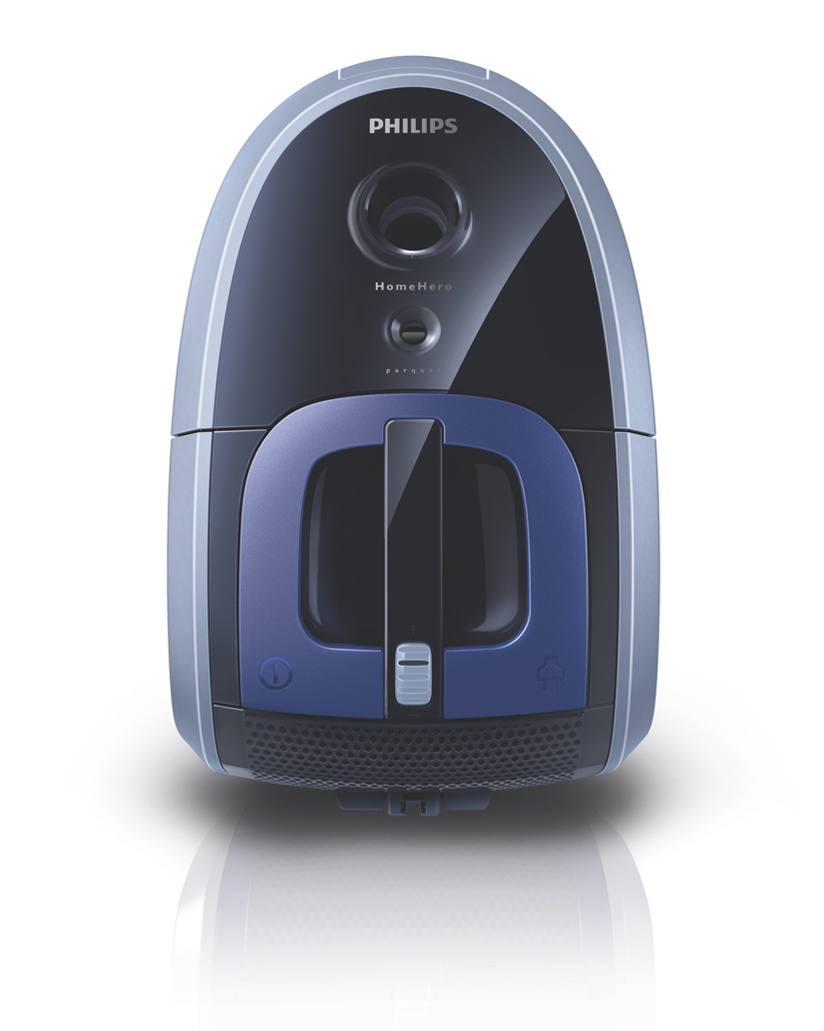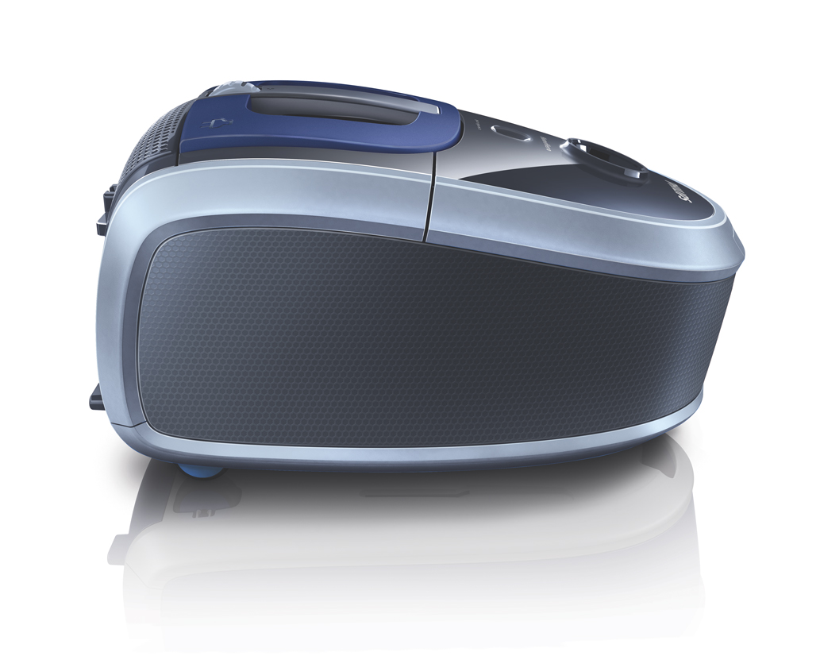FC8917, FC8918

Category: Floorcare
Author: Willem Brouwer
Date: 2009-04-17
Version: Final V1.0
AKB nummer: AKB 32WB-0900007
No. of pages: 10
CMM: Geert van de Pol

(Please place a scan signature)

Date:
Index

1 Introduction, planning 3
1.1 General Introduction 3
1.2 IPD milestones 4
1.3 Introduction Regions/countries, Quantities, Price 4
1.4 Consumer Service Offering (CSO) and repair process 4
2 Technical specifications 5
2.1 Range overview 5
2.2 product specifications 5
2.3 Commercial Accessories 5
3 Architecture and characteristics 6
3.1 Mechanical 6
3.2 Electrical 6
3.3 Critical spare parts 7
3.4 Consumer replaceable parts 7
4 Consumer cost of non Quality prediction 7
4.1 CPI (Cost per Intervention), Expected call center costs and total CoNQ prediction 7
4.2 FCR (field call rate) 8
4.3 Fast feedback program 8
5 consumer care package planning 9
5.1 Consumer care package 9
5.2 special phone number 9
5.3 FAQ (Frequently Asked Questions) 9
Attachment 1: Explanation abbreviations 10

1 Introduction, planning

1.1 General Introduction

Philips Floor Care’s ambition is to extend to market leadership!
Objective:
The FC8910 series will to contribute to this ambition by:

-Strengthening our nr 3 position in the bag segment (WE) especially in the low-mid end segment

-Improve people’s life at home by enhancing the value and role of their floor space at
home

FC8910 series is developed for the Happy Home

Customer:
“I consider a clean home very important to enjoy my life at home. Therefore I would like to have a vacuum cleaner that cleans well while fitting my home interior. However, I am not looking for any frills. Wouldn’t it be great if there was a vacuum cleaner that only focuses on those features that matter?”

1.2 IPD milestones


IR
AA
PPC
PV
CR
PE
VPD
IR
PC
CC
Project Plan Committed PPC: wk918
Commercial Release CR: wk1010

1.3 Introduction Regions/countries, Quantities, Price

Type | Total Sales Europe | Total Sales LatAm | Total Sales APMEA | Total sales per type
FC8912 | 153000 | 5000 | 22000 | 180000
FC8913 | 129000 | 4000 | 21000 | 154000
FC8915 | 204000 | 7000 | 32000 | 243000
FC8917 | 182000 | 0 | 20000 | 202000
FC8918 | 182000 | 0 | 20000 | 202000
Total | 697.000 | 11.000 | 93.000 | 801.000

 | FSP USD | FSP € | Average IIP | Average NNP | Going Price
FC 8912 | USD 43,15 | € 32,36 | € 46,60 | € 62,14 | 119
FC 8913 | USD 43,67 | € 32,75 | € 47,16 | € 62,88 | 119
FC 8915 | USD 45,15 | € 33,86 | € 48,76 | € 65,02 | 139
FC 8917 | USD 47,36 | € 35,52 | € 51,15 | € 68,20 | 149
FC 8918 | USD 47,88 | € 35,91 | € 51,71 | € 68,95 | 149

1.4 Consumer Service Offering (CSO) and repair process

Region | CSO  Front end | CSO  Back end | Repair process
Europe | Call center  Web support FAQ  User manual  Leaflet | Repair/ carry in | Module swap / scrap
Latam | Call center  Web support FAQ  User manual  Leaflet | Repair/ carry in | Module swap / scrap
APMEA | Call center  Web support FAQ  User manual  Leaflet | Repair/ carry in | Module swap / scrap

2 Technical specifications

2.1 Range overview

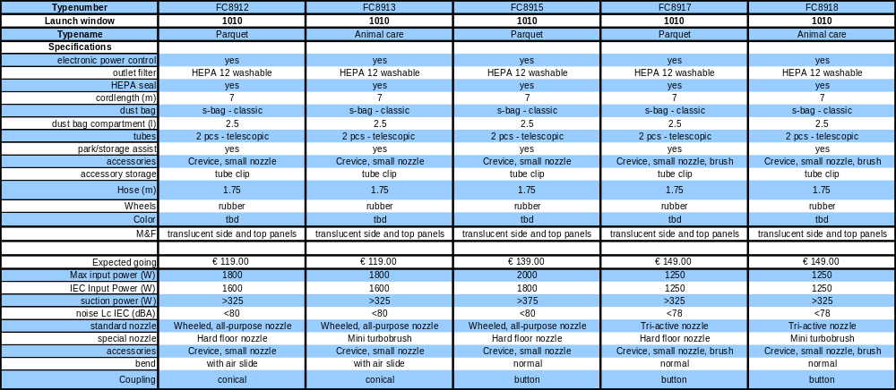

2.2 product specifications

Excellent cleaning results
- 2000 Watt motor generates max. > 325 Watt suction power (FC8613)
- 1800 Watt motor generates max. > 300 Watt suction power (FC8612)
Safe energy, not power
New 1250 Watt HD motor generates max. >325 Watt suction power
(FC8917)
Convenient to use on stairs
Easy to move thanks to two comfortable carrying handles (FC8910-FC8920)
Highly efficient anti-allergy system
HEPA AirSeal and HEPA 12 washable filter (FC8910-FC8920)
Protection for your parquet floor
Parquet nozzle for careful cleaning of hard-floors (FC8912, FC8915, FC8917)
Outstanding results on carpets and furniture
Turbo Brush nozzle for better hair and dust removal (FC8912, FC8915, FC8917

2.3 Commercial Accessories

The commercial available parts are existing typenumbers:
- Dustbags: FC8021, FC8022, FC8023
- Filters: FC8031

3 Architecture and characteristics

3.1 Mechanical

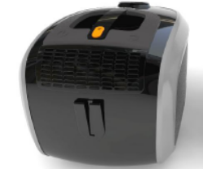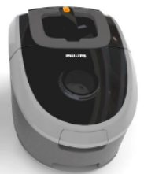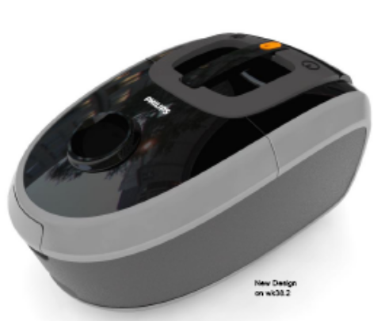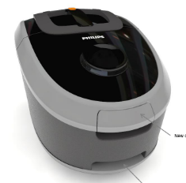
Product design
Product
Electronic power control
Easy to operate on/off & cord winder button
Comfortable top carrying handle
Front carrying handle
Dimensions:
Length:440 mm
Width: 277 mm
Height:253.7 mm

3.2 Electrical

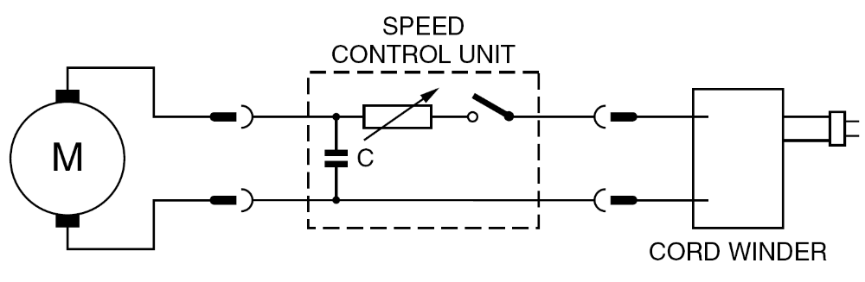

3.3 Critical spare parts

-Motor
-Printed Circuit Board
-Cord winder
-Inlet filter
-Exhaust filter
-Hose assembly
-Tube assembly
-Nozzle(s)
-Dust bag holder

3.4 Consumer replaceable parts

-Dustbags: FC8021, FC8022, FC8023
-Filters: FC8031
-Inlet filter
-Hose assembly
-Tube assembly
-Nozzle(s)
-Dust bag holder

4 Cost of non Quality prediction

4.1 CPI (Cost per Intervention), Expected call center costs and total CoNQ prediction
 | CPI repair € | CPI exchange € | Exchange vs repair rate | CPI mix € | FCR | Total sales | CoNQ total | Retial price (NNP)
Europe | 33,10 | 53,63 | 5% | € 34,12 | 1,89% | 697.000 | € 450.194 | € 65,50
LatAm | 10,80 | 50,43 | 2% | € 11,59 | 1,89% | 11.000 | € 2.413 | € 65,50
APMEA | 11,46 | 50,33 | 1% | € 11,84 | 1,89% | 93.000 | € 20.851 | € 65,50
Total sales |  |  |  |  |  | 801000
CPI (avg/weighted) |  |  |  | € 31,23
Call center cost Europe |  |  |  |  |  |  | € 80.100
Call center cost APMEA |  |  |  |  |  |  | € 8.010
CoNQ (Euro) |  |  |  |  |  | Total CoNQ | € 553.559
CoNQ (% sales) |  |  |  |  |  |  | 1,06%

4.2 FCR (field call rate)

Best estimation at PPC is 1,9%



4.3 Fast feedback program

Feedback | regions | Quantity | cost
Rapid exchange | Europe:  Germany/The Netherlands | 50+50 | € 6550
Total fast feedback costs |  |  | € 6550

5 consumer care package planning

5.1 Consumer care package

 |  | Europe | Latam | APMEA
In-box
 | User Manual | At CR | At CR | At CR | ARC
 | Quick Start Guide | n.a. | n.a. | n.a. | ARC
 | Consumer Care Leaflet** | At CR | At CR | At CR | DFU
Web
 | Warranty Policy Statement (.wbo) | At CR | At CR | At CR
 | Leaflet and Photo's | At CR | At CR | At CR | DFU/ARC
 | FAQ's | At CR | At CR | At CR | ARC
 | Tips and Tricks | At CR | At CR | At CR | ARC
 | Instruction movies (tutorials) | n.a. | n.a. | n.a. | Marcon
Call Center
 | Callcenter Scripts and Tips | At CR | At CR | At CR | CCQ/ARC
 | Training package - technical and soft skills | At CR | At CR | At CR | CCQ/ARC
 | Training execution | At CR | At CR | At CR | CCQ/ARC
 | Product samples | At CR | At CR | At CR | CCQ/ARC
Repair & Exchange
 | Service Manual | At CR | At CR | At CR | CCQ
 | Diagnostics- and Service Tools | n.a. | n.a. | n.a. | CCQ
 | Service Bill of Material, incl. spare parts Purchasing Master data | At CR-2WK | At CR-2WK | At CR-2WK | CCQ
 | Training package diagnostics & repair | n.a. | n.a. | n.a. | CCQ

5.2 special phone number

For Europe,Latam, Apmea; 800-number Will be added to user manual and quick start guide
(To be confirmed by CCM April 2009)

5.3 FAQ (Frequently Asked Questions)
FAQ will be translated in to following languages.
- English, French, Danish, Spanish, Italian, Dutch (for all versions)
- Portuguese
- Chinese Simplified and Traditional Chinese

Attachment 1: Explanation abbreviations

VPD: Value Proposition Debriefing
AA: Assignment Agreed
PPC: Project Plan Committed
CC: Concept Consolidation
PC: Prototype Consolidation
PV: Product Validated
IR: Industrial Release
CR: Commercial Release
PE: Project end

FSP: Factory Standard Price
IIP: Internal Invoice Price (FSP + NSO kost)

DFU: Direction For Use
FAQ: Frequently Asked Questions
CSO: Consumer Service Offering
ConQ: Cost of non Quality

ACR: Average contact Rate
FCR: Field Call Rate

LATAM = Latin America
Nafta = North America, Canada and Mexico
APMEA = Asian Pacific, Middle East, Africa
Europe = Europe

