
Consumer Lifestyle

Consumer Care Book
Adalar
FC 6150 / FC6152

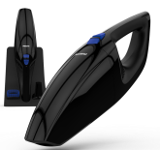

Consumer Marketing Manager

To be approved via PPIM

Approval

Author: | Niels Goedvolk / Yvonne Dingsté
Date: | 26-08-2014
AKB: | AKB224F-140301
Category: | DA-Floorcare
Status: | Final
Version: | PPC
AKB-number generator

Product information

Adalar is the successor of FC6050/99 and FC6140 of 3.6V Handheld VC target to launch in Q1, 2015 in Europe. The objective is to restore the profitability and outlook refreshment for a modern look.

VPH
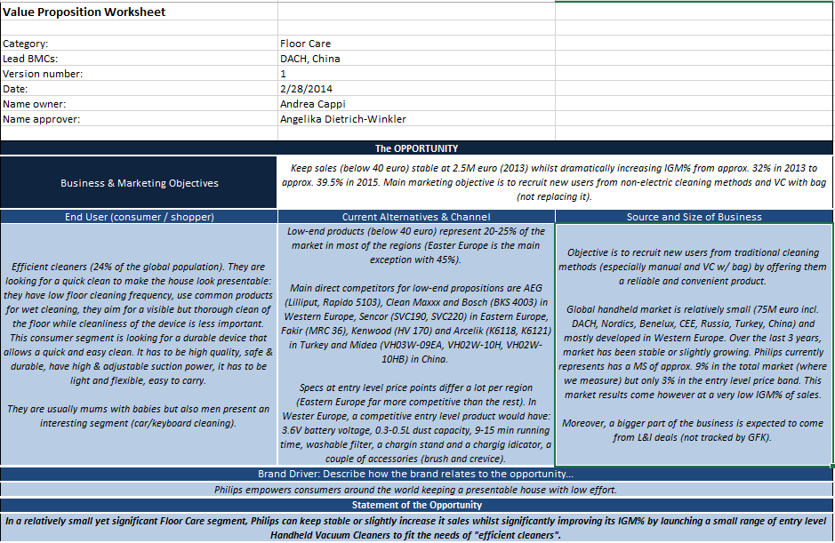

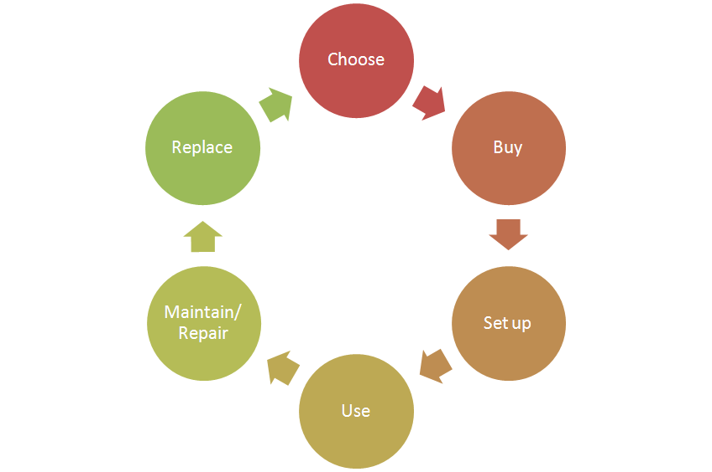
Consumer care focus:
For this product we carry out the standard consumer care package +
- Choose:
- Buy:
- Setup:
- Use:
- Maintain/repair: focus on battery replacement
- Replace:

CRM strategy:
Integration CRM (compelling reason for registration, in box communication, follow up upon registration)

Sales introduction and IPD milestone planning
Business Market Combination (BMC) | Launchdate (LD) | Planned sales intro year /BMC  (x1000) | Total planned sales /BMC  (x1000)
Africa | WK 1502 | 1 | 8,5
China | WK 1502 | 16 | 215
Europe | WK 1502 | 2,5 | 206,5
United Arab Emirates | WK 1502 | 6,5 | 62,5
Korea | WK 1502 | 10 | 95
Asean Pacific | WK 1502 | 1,7 | 22,1


IR
AA
PPC
PV
CR
PE
VPD
IR
PC
Project Plan Committed PPC: WK1434
Serviceable parts identified.
Product Validated PV: WK1452
Input: supplier factory codes and price for all Spare Parts.
Input: Exploded view / 3D cad file + BoM list.
Industrial Release IR: WK1502
Reservce capacity (50-100 pcs) of all identified spare parts.
Commercial Release CR: WK1502

Warranty and service policy

- 2 Year warranty
- Replacement ??.

Proposed Accessories & Consumer Replaceable Parts

Spare part | Commercial Accessory | Online shop price
Crevice nozzle
Brush nozzle
Base + adaptor
Dustbin assy
Filter assy
Complete handheld ??

CoNQ prediction & cost driver assumption

CoNQ as % of sales: 11,8 %
CREX Best estimate: 2 %
CPI: € 5,53
Call center cost as % of sales: 0,01 %

Consumer care package
Item | Detail | Availability timing | Owner | Cost (T.I.C) / Marcom budget
In-box
 | User Manual | PV (text)  IR (final) | Marijke Semmelink
 | Quick Start Guide | IR | Marijke Semmelink
 | World Wide Guarantee Card | IR | Marijke Semmelink
 | Inbox leaflet | IR | Jacqueline Poon
 | Worldwide guarantee leaflet | IR | Marijke Semmelink
Web
 | Leaflet and Photo's | CR | Jacqueline Poon
 | Specifications in leaflet covered (size, dimensions, weight etc.) (PFS) | CR | Jacqueline Poon
 | Accessory information linked to CTN’s / online (PFS) | CR | Yvonne Dingsté
 | Pre-purchase FAQ's | CR | Niels Goedvolk
 | Post-purchase FAQ's | CR | Niels Goedvolk
 | Tips & Tricks | CR | Niels Goedvolk
 | Web reviews | CR | Niels Goedvolk
Call Center
 | Training package - technical and soft skills | IR | Niels Goedvolk
 | Training execution (Powerpoint/online/onsite) | CR | Niels Goedvolk | €
 | Commercial Product samples | IR | Jacqueline Poon | €
 | Call center Feedback | CR | Niels Goedvolk | €
Service Centers
 | Service Manual | CR | Yvonne Dingsté | €
 | Service Bill of Material, incl. spare parts Purchasing Master data | CR - 2WK | Yvonne Dingsté
 | Training package diagnostics & repair | CR | Yvonne Dingsté

Consumer experience feedback loop
Consumer feedback from call centers and web reviews until 6 months after launch.

