Consumer Care Book
Bread Makers

Category: Kitchen Appliances
Author: Ruud Verbeek
Date: 2009/04/16
Version: Draftv1.3
AKB nummer: AKB 32RV-0900017
No. of pages: 18
CMM: Daniela.de.Alba.Jarquin

(Please place a scan signature)

Date: YEAR/MM/DD
HD9020 & HD9040

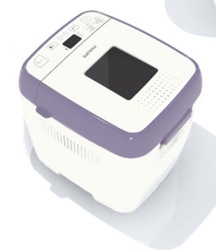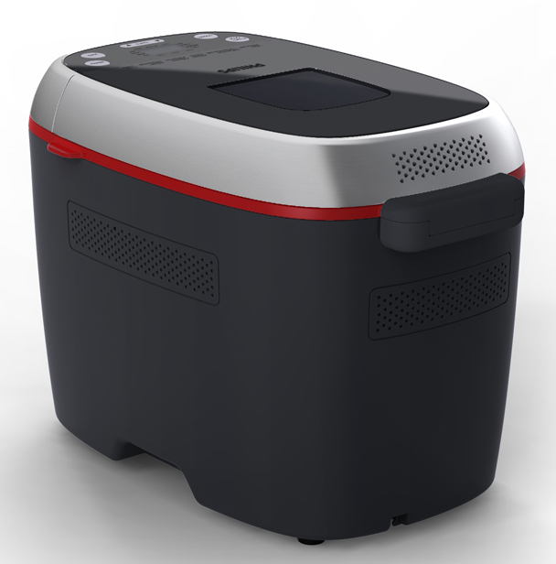
Index

1 Introduction, planning 3
1.1 General Introduction 3
1.2 IPD milestones 4
1.3 Introduction Regions/countries, Quantities, Price 4
1.4 Total predictions of sales (sales in Year / total sales) 5
1.5 Consumer Service Offering (CSO) and repair process 6
1.6 Consumer (CRM) & Loyalty 6
2.1 Range overview 7
2.2 Product specifications 8
2.3 New commercial features 8
2.4 Commercial Accessories 8
3 Architecture and characteristics 9
3.1 Mechanical 9
3.2 Electrical 9
3.3 Critical spare parts 10
3.4 Consumer replaceable parts 10
4 Cost of non quality prediction 11
4.1 Call center cost 11
4.2 CPI (Cost per Intervention) & Expected call center costs 11
4.3 Predicted Field Quality (PFQ) or Field Call Rate (FCR) 11
4.4 ConQ (Cost of non Quality) 12
4.5 Charge back agreement 13
4.6 Initial Stocking confirmation 13
4.7 Fast feedback program 14
5 Consumer care package planning 15
5.1 Consumer care package 15
5.2 Special phone number 16
5.3 FAQ (Frequently Asked Questions) 16

Attachments 17
Attachment 1: Explanation abbreviations 17
Attachment 2; Overview Countries 18

1 Introduction, planning

1.1 General Introduction

The bread maker is a new product range within Philips. The HD9020 & HD9040 is the first Bread maker appliance. This project is under the responsible of project leader Kelvin Liu in Hong Kong.

The bead Makers will produce by Elec-Tech International Co., Ltd.

“Automatics” : New users, basic users – look mainly for

  - Enjoy fresh bread but currently don’t bake at home because it’s considered “difficult” to do.
  - May be uncertain of the functionality of bread machines.
  - Want all the benefits of fresh just baked bread but without much intervention required
  - Can be triggered to experiment adding ingredients

“Semi-automatics” : Already bake at home with or without an appliance, more advanced or informed users – look mainly for

  - Enjoy fresh bread and want more control and versatility in the process
  - The bread machine is mostly a ‘helper’ in their baking pleasure to do the hardest tasks but still enjoying modeling the process., but don’t want to give up the automatic full-process option.
  - Various shapes and bigger sizes are important
  - Want to experiment more with ingredients

1.2 IPD milestones


IR
AA
PPC
PV
CR
PE
VPD
IR
PC
CC

HD9020
 | VPD | AA | PPC | PV | IR | CR | LD | PE
 | 0845 | 0851 | 0911/  0912 | 0934 | 0940 | 0945 | 0952 | 1023

HD9040
 | VPD | AA | PPC | PV | IR | CR | LD | PE
 | 0845 | 0851 | 0918 | 0945 | 0949 | 1002 | 1010 | 1034

1.3 Introduction Regions/countries, Quantities, Price

Type number | Region  Stroke version | First shipment | Total  Planned quantity | FSP | IIP (Invoice price) | net – net price | Going  price
HD9020 | Europe | Wk 940 | k 240 | € 27.30 | € 39.22 | € 53, | € 100,
 | Latam | Wk940 | k 45 | € 27.30 | € 39.22 | € 53, | € 100,
 | APMEA | Wk940 | K6 | € 27.30 | € 39.22 | € 53, | € 100,

Type number | Region  Stroke version | First shipment | Total  Planned quantity | FSP | IIP (Invoice price) | net – net price | Going  price
HD9040 | Europe | Wk949 | k 165 | € 45.- | € 58.61 | € 79.20 | € 150,
 | Latam | Wk949 | k 22 | € 45. | € 58.61 | € 79.20 | € 150,
 | APMEA | Wk949 | K3 | € 45. | € 58.61 | € 79.20 | € 150,

1.4 Total predictions of sales (sales in Year / total sales)

HD9020 = 291 K over 5 years
HD9040 = 200 K over 5 years

* Overview countries see attachment 2

1.5 Consumer Service Offering (CSO) and repair process

Region | CSO  Front end | CSO  Back end | Repair process
Europe | Call center FAQ  Web support FAQ  DFU / User manual  Leaflet | West Europe Replace  East Europe Repair | Components replace
Latam | Call center FAQ  Web support FAQ  DFU / User manual  Leaflet | Repair | Components replace
APMEA | Call center FAQ  Web support FAQ  DFU / User manual  Leaflet | Repair | Components replace

* Source; Daniela de Alba Jarquin
* The DFU is providing with the Quick start guide.

1.6 Consumer (CRM) & Loyalty

n.a
2 Technical specifications

2.1 Range overview

HD9040
- Sophisticated & stylish design
- Shape variety backing rack*
- Capacity: 750gr, 1kg, 1.5Kgr XXL market size
- 14 programs
- 2 paddles for superior kneading process and improved bread texture
- Rapid Bake (1hr)
- Signal for adding extra ingredients
- 15 hours delayed time
- 3 crust color selection
- Keep warm function
- View window
- Easy to use measuring cup and spoon PLUS cutting blade and brush for personalization
- 850 W

HD9020
- Compact & modern design
- Capacity: 500gr, 650gr, 1Kg
- 12 programs
- Rapid Bake (1 hr)
- Signal for adding extra ingredients
- 13 hours delayed timer
- 3 browning tone selections
- Keep warm function
- View window
- Easy to use measuring cup and spoon included
- 650 W

Main difference between HD9020 and the HD9040?

HD9020 | HD9040
500gr - 750gr - 1kg | 750gr – 1kg – 1.5kg
12 Programs | 14 Programs
13 hours delay timer | 15 hours delay timer
650W | 850W
 | Extra accessories: baking brush and cutting blade for personalization
 | Additional baking rack for shape variety
 | 2 mixing paddles for superior kneading process and improved bread texture

2.2 Product specifications

Voltage: 220-240V

Power consumption: HD9020 = 650 W
HD9040 = 850 W
Standby power:
Frequency: 50-60Hz
Demention:
Wight:

2.3 New commercial features

All Features are new. This is the first bread maker for Philips.

2.4 Commercial Accessories
n.a

3 Architecture and characteristics

3.1 Mechanical
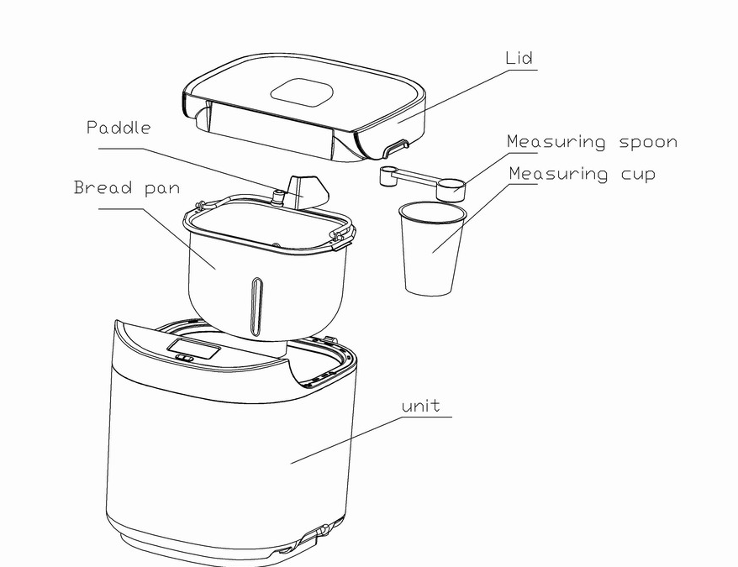

3.2 Electrical
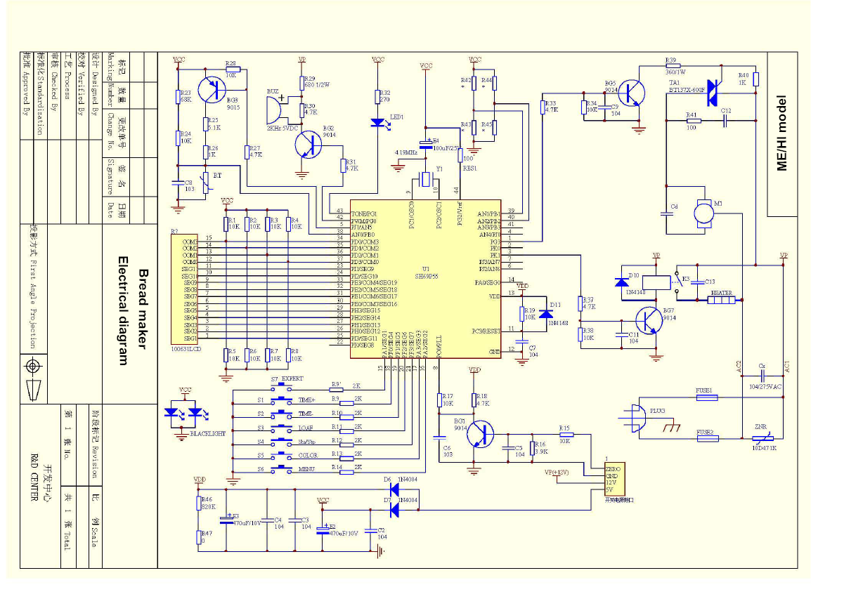

3.3 Critical spare parts

  - Bread pan
  - Baking racks
  - Cutting blade

3.4 Consumer Replaceable Parts
HD9020 & HD9040CRP
Spoon bread pan measuring cup Padel
(Leading blade)
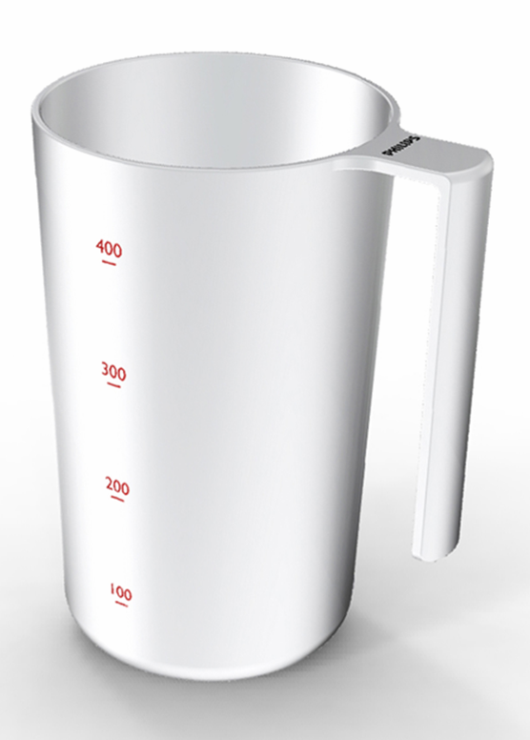
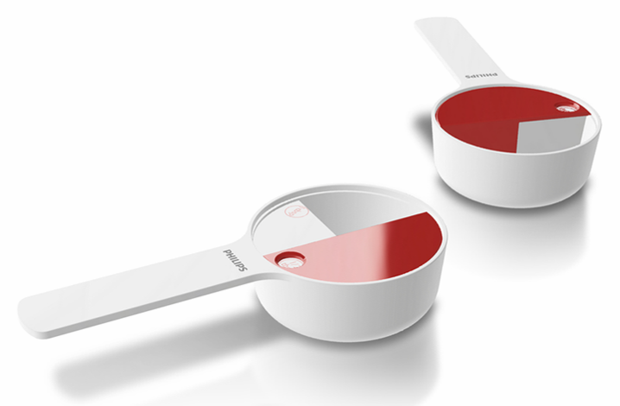
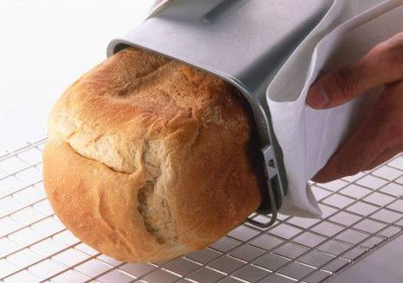
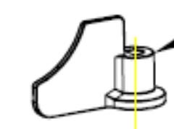

HD9040 only CRP
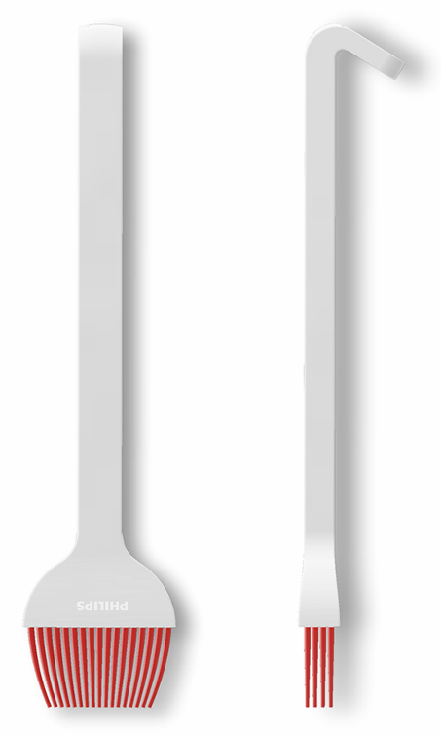
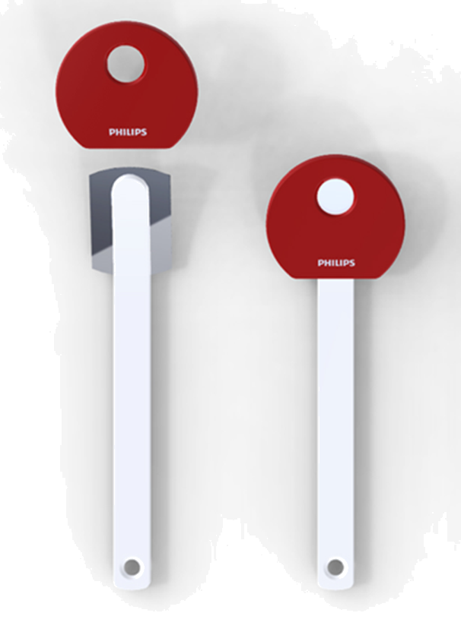
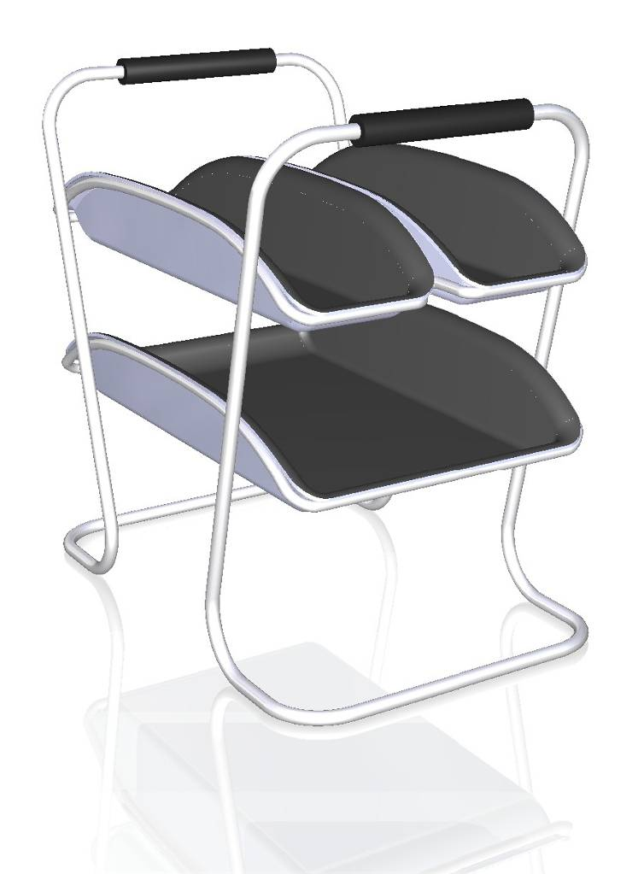
Baking racks Cutting blade Brushes

4 Cost of non quality prediction

4.1 Call center cost

No specified Bread maker cost per call available. We use the cost per call for all KA products and all amounts of KA calls in 2008.

(Cost per cal = average time * cost per minute)
Region | Type Number | Amount of calls | Total Sales | ACR | Average call time | Price per minute | Cost per call
Europe | All KA products | 53306 | 21.000.000 | 0.25% | 8.5 min | € 1,- | € 8.50

- No specified steamer cost per call available. We use the cost per call for all KA product
- ACR = Amount of calls / total sales
- Overview call see attachment 2

4.2 CPI (Cost per Intervention) & Expected call center costs

* see ConQ 4.4

4.3 Predicted Field Quality (PFQ) or Field Call Rate (FCR)

HD9020
  - FCR = 2.5%

HD9040
  - FCR = 2.6%

4.4 ConQ (Cost of non Quality)

HD9020

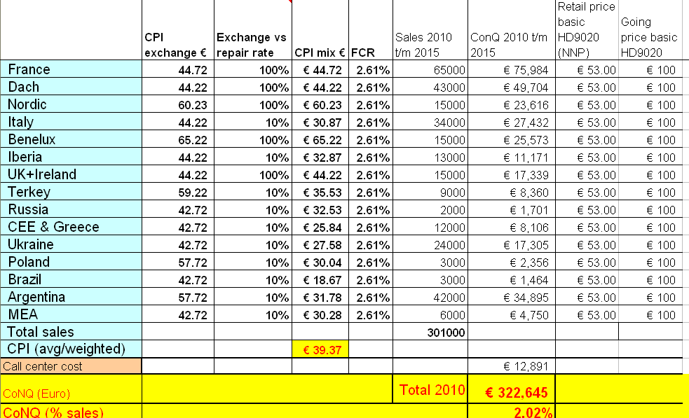

HD9040
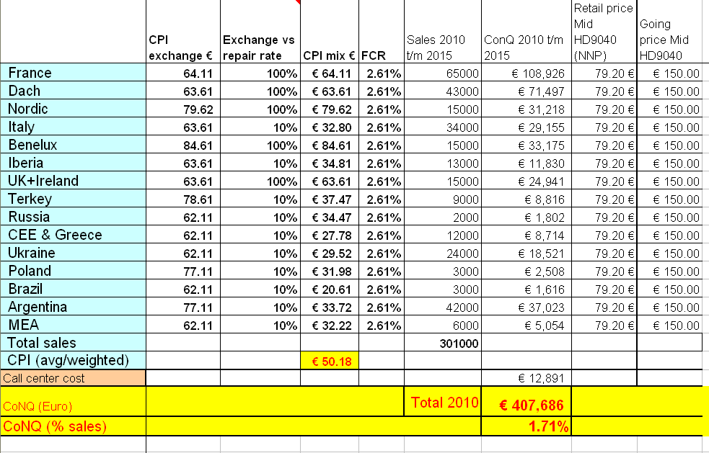

4.5 Charge back agreement
The claim compensation is based on epidemic failure or excess the rate specify in Quality Contract (from Quality team and individual Quality contract will be defined for each model), our quality team will support us to define failure in connection with or arise from supplier’s failure, then we will discuss and settle with supplier based on quality judgment & case by case.

Chargeback is not arranged yet (2009-06-25)

* Source; Irene Yeung

4.6 Initial Stocking confirmation
N.a

4.7 Fast feedback program

Feedback | regions | Quantity | cost | Yes / No
Repair via initial workshop? | Europe | - | € | no
Call center feedback | Europe | First 50 calls | € | yes
Web feedback | Europe | First 50 web/email massage | € | yes/no
Rapid exchange | Europe, HD9020 | 100 | € 5000,- | yes
Rapid exchange | Europe, HD9040 | 50 | € 2500,- | yes

Total fast feedback cost | € 7.500,-

* Estimate cost for one return appliance = 50, - Euro
* For new product range we will analyze the first 100 appliances.

5 Consumer care package planning

5.1 Consumer care package

 |  | Europe | Latam | Nafta | APMEA | Accountable
In-box
 | User Manual / Quick Start Guide | 943 | 943 | 943 | 943 | ARC / DFU
 | Quick Start Guide | 943 | 943 | 943 | 943 | ARC
Web
 | Warranty Policy Statement (guarantee leaflet) | 943 | 943 | 943 | 943 | DFU
 | Leaflet and Photo's | 943 | 943 | 943 | 943 | DFU/ARC
 | FAQ's | 943 | 943 | 943 | 943 | ARC
 | Tips and Tricks | 943 | 943 | 943 | 943 | CMM / Marcom
 | Instruction movies (Call center) | 943 | 943 | 943 | 943 | Marcom
Call Center
 | Call center Scripts and Tips | 939 | 939 | 939 | 939 | CCQ/ARC
 | Call center training kit | 939 | 939 | 939 | 939 | CCQ/ARC
 | Training execution | 939 | 939 | 939 | 939 | CCQ/ARC
 | Product samples | 939 | 939 | 939 | 939 | CMM
Repair & Exchange
 | Service Manual | 939 | 939 | 939 | 939 | CCQ
 | Samples | 939 | 939 | 939 | 939 | CCQ / CMM
 | Service Bill of Material, incl. spare parts Purchasing Master data | 939 | 939 | 939 | 939 | CCQ
 | Training package diagnostics & repair | 940 | 940 | 940 | 940 | CCQ
 | Training execution | 940 | 940 | 940 | 940 | CCQ

5.2 Special phone number

For Europe, Nafta, Latam, Apmea; 800-number Will be added to user manual and quick start guide


5.3 FAQ (Frequently Asked Questions)
FAQ will be translated in to following languages.

  - English,
  - French,
  - Danish,
  - Finnish,
  - Spanish,
  - Italian,
  - Dutch,
  - German,
  - Norway,
  - Swedish,
  - Turkish,
  - Russia,
  - Portuguese

  - Farsi,
  - Arabic

  - (CEE) Estonia, Latvia, Lithuania, Czech Republic, Slovakia, Hungary, Romania, Bulgaria, Macedonia, Serbia, Albania, Montenegro, Bosnia and Herzegovina, Creatia, slovenia,
  - Ukraine

Attachments

Attachment 1: Explanation abbreviations

VPD: Value Proposition Debriefing
AA: Assignment Agreed
PPC: Project Plan Committed
CC: Concept Consolidation
PC: Prototype Consolidation
PV: Product Validated
IR: Industrial Release
CR: Commercial Release
PE: Project end

FSP: Factory Standard Price
IIP: Internal Invoice Price (FSP + NSO kost)

DFU: Direction For Use
FAQ: Frequently Ask Questions
PFQ: Predicted Field Quality
CSO: Consumer Service Offering
ConQ: Cost of non Quality

ACR: Average contact Rate
FCR: Field Call Rate
FAQ: Frequently Ask Questions.

LATAM = Latin America
Nafta = North America, Canada and Mexico
APMEA = Asian Pacific, Middle East, Africa
Europe = Europe

Attachment 2; Overview Countries
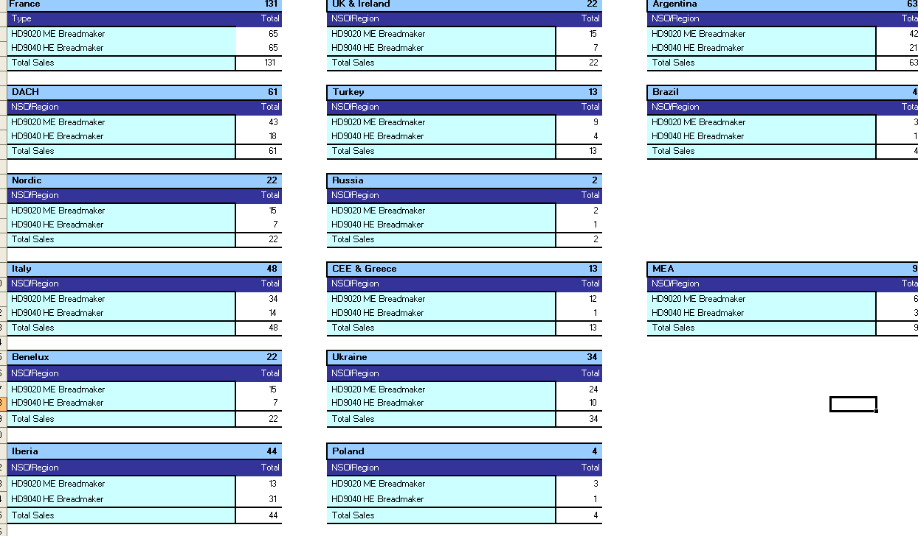

Remarks ruud

- Project leader : Kelvin Liu
- CMM : Daniela.de.Alba.Jarquin
- DQD : Daren Wright
- Purchase : Irene Yeung
- Consumer Care : Ruud Verbeek
- ARC : Daphne Leving

110-127V (RI9020 & RI9040)? Brazil version depends on quantities

Instruction movie not planned yet. ?????? maybe call centers

