
Consumer Lifestyle

Consumer Care Book
Atlas
FC865x

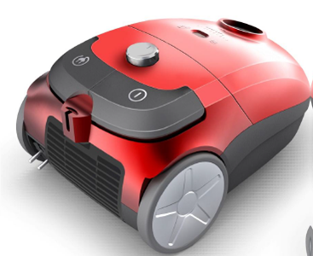

Consumer Marketing Manager

To be approved via PPIM

Approval

Author: | Niels Goedvolk, Yvonne Dingsté
Date: | 21-03-2013
AKB: | AKB 229F-130660
Category: | DA-Floorcare
Status: | Draft
Version: | PPC
AKB-number generator

Product introduction

Business objectives:
1. Succeed to Easy Life Bag counting for 17% of our sales in Bag segment (14M€)
2. Maintain & build market share at mid bag price points (€99-€129)
3. Provide Retailers with a strong competitive canister at critical price point of 99€ and bridge the gap towards PerformerPro
Target Group: Blue and Black segments

Marketing objectives:

1.Increase preference vs. competitor in the price segment of 99€-129€
2. Upgrade consumers from PowerLife towards Atlas

VPH

For Atlas project the general VPH of Floorcare is valid.

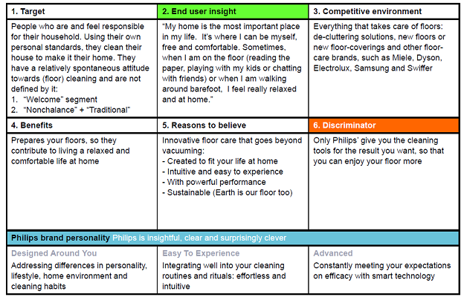

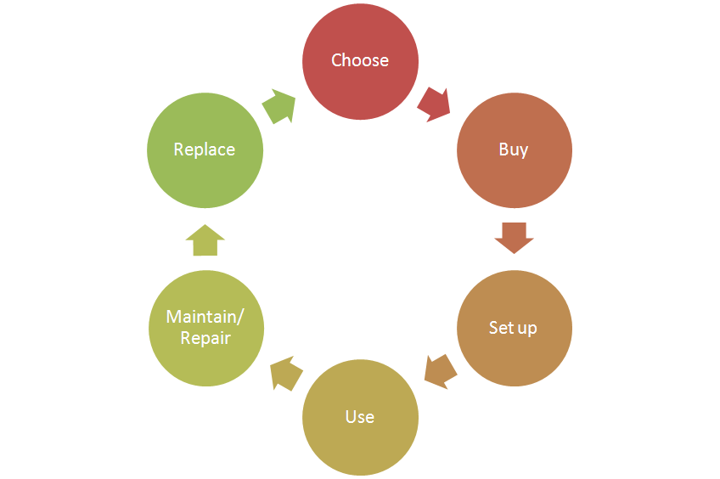
Consumer care focus:
For this product we carry out the standard consumer care package +
- Choose: support benefits by clear communication of the specificastions.
- Buy:
- Setup:
a) Supporting the accessories included (list available accessories and where to buy to enable consumer to upgrade)
- Use:
- Maintain/repair:
a) Product experience enhancement especially why, how to clean the filters, where they are located and how to purchase.
- Replace:

CRM strategy:
EU: Registration card added.

Sales introduction and IPD milestone planning
Business Market Combination (BMC) | Launchdate (LD) | Planned sales intro year /BMC  (x1000) | Total planned sales /BMC  (x1000)
Russia | WK1345 | 15 | 55
CEE | WK1343 | 25 | 92.5
DACH | WK1343 | 35 | 129
Benelux | WK1343 | 35 | 129
France | WK1343 | 5 | 23.5
Poland | WK1343 | 5 | 13.5


IR
AA
PPC
PV
CR
PE
VPD
IR
PC
Project Plan Committed PPC: WK1312
Prototype Consolidation PC: WK1312
Product Validated PV: WK1331
Industrial Release IR: WK1333
Commercial Release CR: WK1343

Warranty and service policy

- 2 Year warranty
- Repair by component swap.

Proposed Accessories & Consumer Replaceable Parts

Accessories: | Online shop price
Replacement kit including filter and dustbags (tbd) | (Tbd)

Consumer Replaceable Parts | Online shop price
HEPA Filter
Nozzle
Turbo Brush
Accessoires

CoNQ prediction & cost driver assumption

CoNQ as % of sales: 1.05%
CREX Best estimate: 2.14%
CPI: € 22.16
Call center cost as % of sales: 1.9%

Consumer care package
Item | Detail | Availability timing | Owner | Cost (T.I.C) / Marcom budget
Front-end Touchpoints
In-box
 | User Manual | PV (text)  IR (final) | Aymen Mnif
 | Quick Start Guide | IR | Aymen Mnif
 | Inbox leaflet | IR | Aymen Mnif
 | Worldwide guarantee leaflet | IR | Aymen Mnif
Web
 | Leaflet and Photo's | CR | Aymen Mnif
 | Specifications in leaflet covered (size, dimensions, weight etc.) (PFS) | CR | Aymen Mnif
 | Accessory information linked to CTN’s / online (PFS) | CR | Yvonne Dingsté
 | Support movies | CR | Niels Goedvolk | €
 | Pre-purchase FAQ's | CR | Niels Goedvolk
 | Post-purchase FAQ's | CR | Niels Goedvolk
 | Tips & Tricks | CR | Niels Goedvolk
 | Consumer Care Leaflet | CR | CEM
 | Web reviews | CR | Niels Goedvolk | €
Call Center
 | Training package - technical and soft skills | IR | Niels Goedvolk
 | Training execution (Powerpoint/online/onsite) | CR | Niels Goedvolk | €
 | Commercial Product samples | IR | Yvonne Dingsté | €
 | Call center Feedback | CR | Niels Goedvolk | €
Back-end Touchpoints
Service Centers
 | Service Manual | CR | Yvonne Dingsté
 | Service Bill of Material, incl. spare parts Purchasing Master data | CR - 2WK | Yvonne Dingsté
 | Training package diagnostics & repair | CR | Yvonne Dingsté

Consumer experience feedback loop
Fast feedback after launch: call center call analysis, Bazaarvoice/ webreview analysis. Bi weekly feedback loop in first months. Over time change to monthly or hold.

