Omnivore final 2.6
04-05-2010

Consumer Care Book
ME Omnivore

HD9220
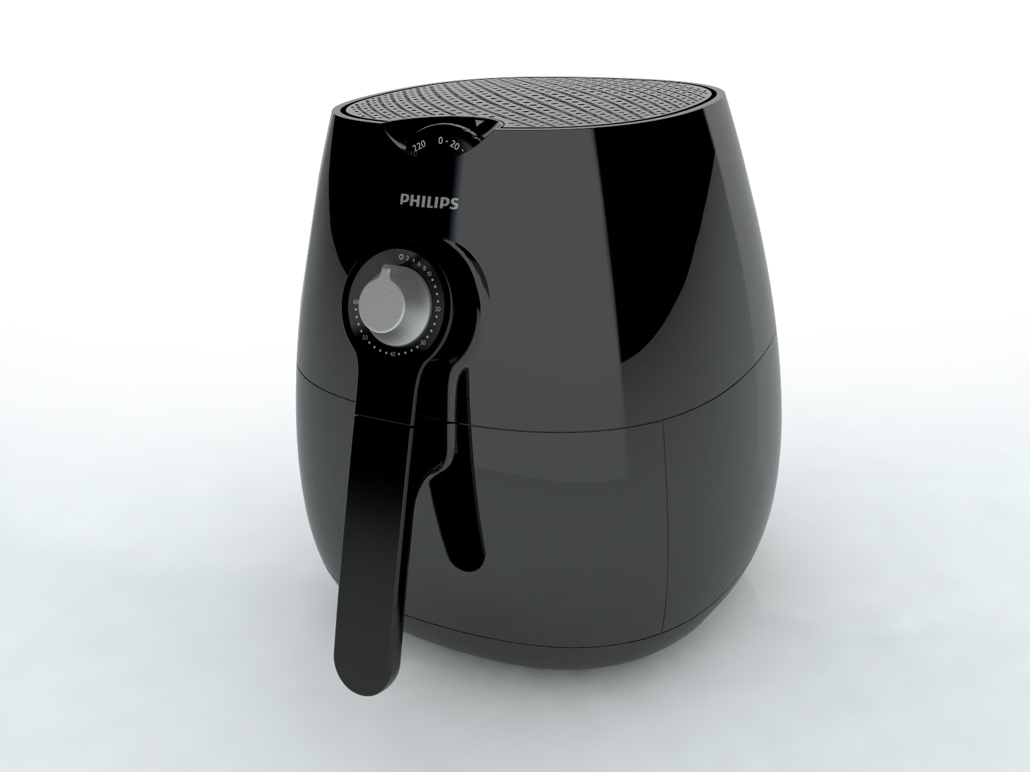

Category: Air fryer
Author: Ruud Verbeek
Date: 2010-01-04
Version: Draft 2.3
AKB nummer: AKB 32RV-0900065
No. of pages: 15
CMM: Michiel kerckheard

(Please place a scan signature)

Date:
Index

1 Introduction, planning 3
1.1 General Introduction 3
1.2 IPD milestones 4
1.3 Introduction Regions/countries, Quantities, Price 4
1.4 Total predictions of sales (sales in Year / total sales) 4
1.5 Consumer Service Offering (CSO) and repair process 5
1.6 Consumer (CRM) & Loyalty 5
General 5
2 Technical specifications 6
2.1 Range overview 6
2.2 Product specifications 6
2.3 New commercial features 6
2.4 Commercial Accessories 6
3 Architecture and characteristics 7
3.1 Mechanical 7
3.2 Electrical 7
3.3 Spare parts for the online shop 7
3.4 Critical 8
3.5 Consumer replaceable parts (CRP) 8
3.6 Normal spare parts 8
4 Cost of non quality prediction 9
4.1 Fast feedback program 9
4.2 Call center cost 9
4.2.1 Cost for answer the phone 9
4.2.2 Call center training 9
4.2.3 A product specialist (feedback loop) 10
4.3 CPI (Cost per Intervention) 10
4.4 Predicted Field Quality (PFQ) or Field Call Rate (FCR) 10
4.5 ConQ (Cost of non Quality) 11
4.6 Loyalty & registration 11
5 Consumer care package planning 12
5.1 Consumer care package (Benelux, France, UK) 12
5.2 Special phone number 14
5.3 FAQ (Frequently Asked Questions) 14
5.4 Call center 14
Attachment 1: Explanation abbreviations 15

1 Introduction, planning

De air fryer is a new way of cooking; you will prepare your food without or less fat. With hot air in a special flow direction and speed you will prepare your food in minutes.

Air fryer offers a versatile and healthy way for food preparation which......

- Is an alternative for using a deep-fryer, oven or furnace
- Operates without oil or fat
- Works faster and better than anything on the market
- Is easy to control and operate
- Can be positioned as a new generation of kitchen appliances
- Can be offered for an affordable consumer price
- Is based on new and exclusive, easy to understand

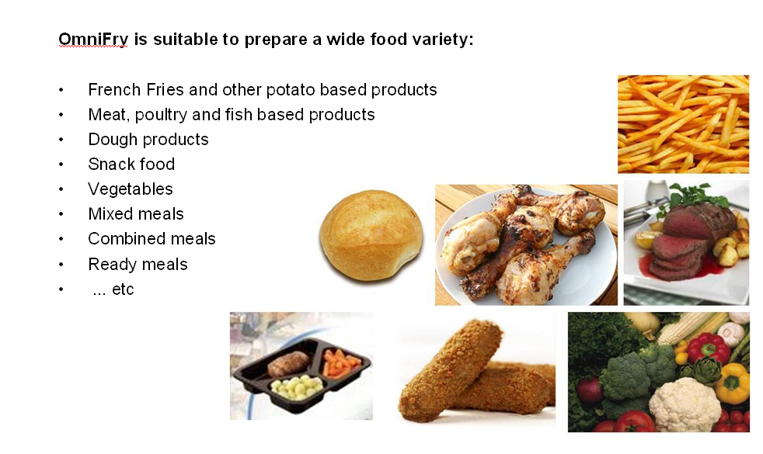

1.1 General Introduction

The air fryer will launch in the follow countries.

September 1010 : France
October 1010 : BeNeLux
December 1010 : UK

March 1011 : DACH, CEE, Iberia, MEA, Poland, Greece, Russia, Ukraine, UK & Ireland, Nordics, Italy

1.2 IPD milestones


IR
AA
PPC
PV
CR
PE
VPD
IR
PC
CC
Project Plan Committed PPC 1009
Prototype Consolidation PC 1015
Product Validated PV 1028
Industrial Release IR 1030
Commercial Release CR 1032

1.3 Introduction Regions/countries, Quantities, Price

Type number | Region  Stroke version | Total  Planned quantity | FSP | IIP (Invoice price) | net – net price | Going  price
HD9220 | all | 648K | € 40,-  $ 55,- | € 72,80  $ 102,- | € 104,-  $ 146,- | € 199,-  $ 279,-
HD9240 | all | 228K | € 56,-  $ 78,- | € 91,70  $ 130,- | € 131.-  $ 174,- | € 250,-  $ 351,-
* IIP = 0.7 * Net- Net price
* Total planned quantity is over 4 years

1.4 Total predictions of sales (sales in Year / total sales)

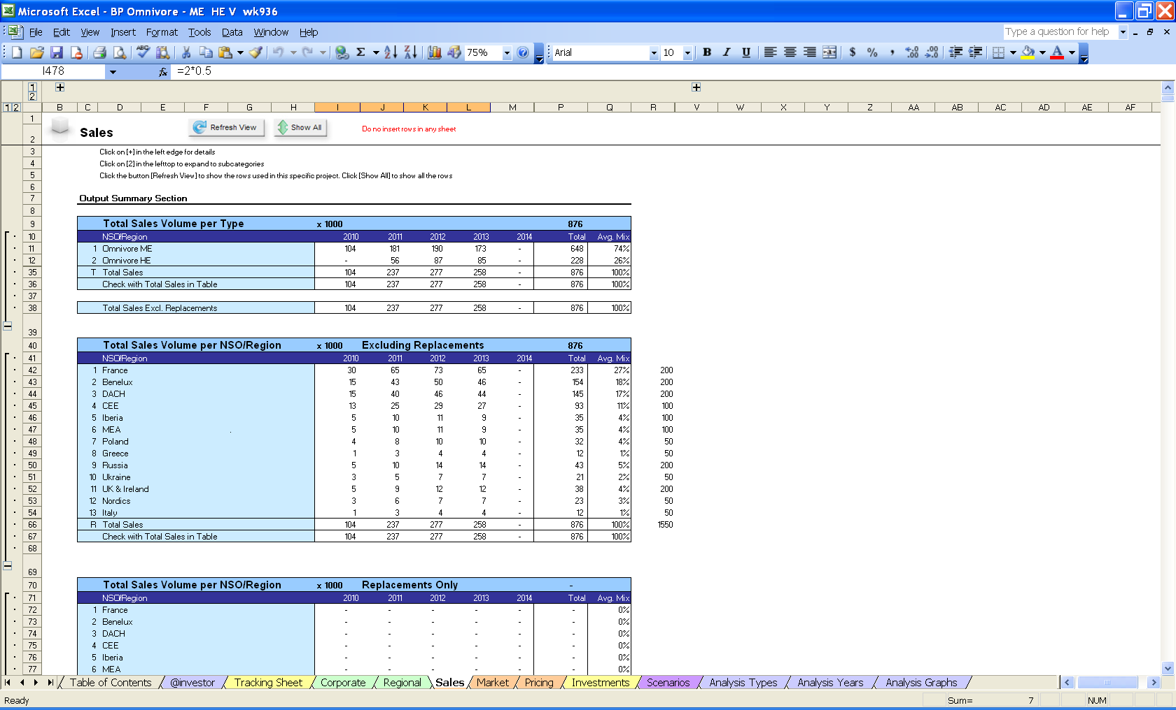

1.5 Consumer Service Offering (CSO) and repair process

Region | CSO  Front end | CSO  Back end | Repair process
Europe | Call center FAQ  Web support FAQ  DFU / User manual  Leaflet  Instruction movies / tutorials  Quick start guide | Repair | Module swap

1.6 Consumer (CRM) & Loyalty

General
Consumer Care and CRM should:
- Stimulate purchase by:
  - creating awareness and familiarity with the product and re-assuring the believability of the proposition through consumer education (pro-actively via pre-sale crm e-mail to target audience and reactively via call center and on line support)
  - lowering the purchase threshold through a free trial/not satisfied-money back offer
- create positive word of mouth and loyalty by enhancing the product usage pro-actively through crm post sale messaging (extra recipes, tips and tricks) and re-actively via call center and on line support (confirming the consumer made the right choice) and usage reactivation upon return from repair
- Enable nps product feedback and augment the crm post sale target audience by stimulate product registration
- accelerate the learning from consumer by installing a dedicated call center feedback loop

2 Technical specifications

2.1 Range overview

- HD9020 ME Omnivore
- HD9020 HE Omnivore

2.2 Product specifications

Voltage: 220-240V
Power consumption: 1400W
Standby power: 0.5 W
Frequency: 50-60 Hz
Dimensions: 280*345*310 L/H
Temp range 80 – 200degC
Supply voltgae 220-240Vac, 50-60Hz, 1400W

2.3 New commercial features

The Air fryer is a new concept of preparing your food.

2.4 Commercial Accessories

N.a

3 Architecture and characteristics

3.1 Mechanical

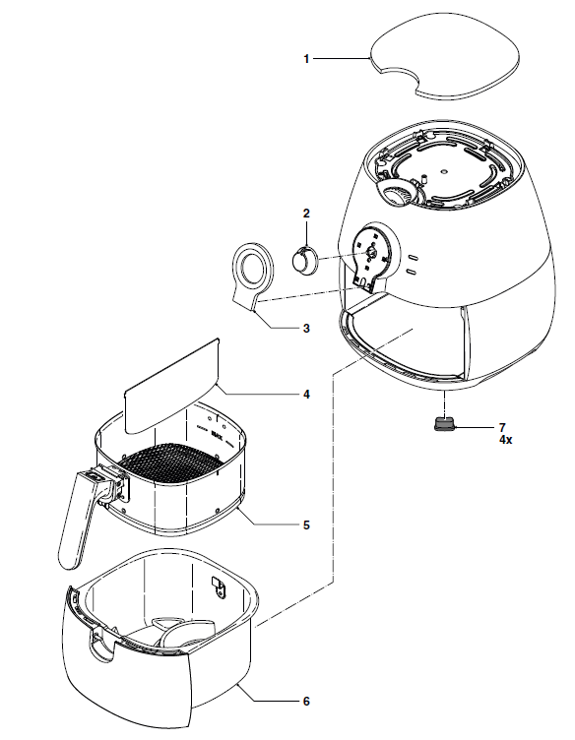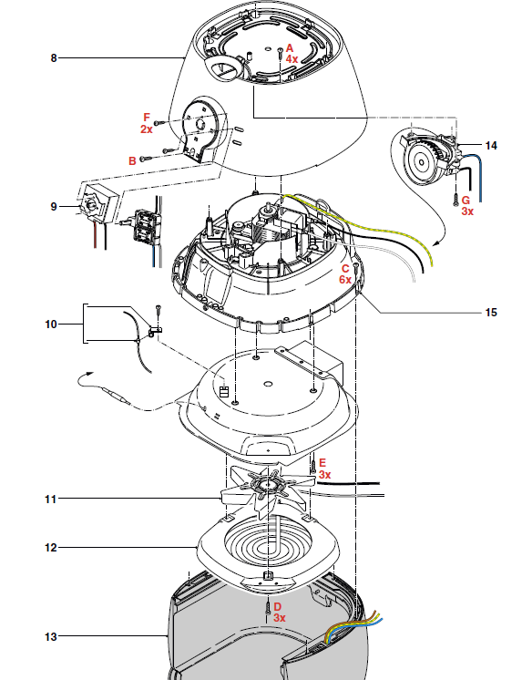

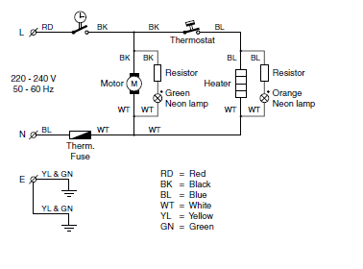
3.2 Electrical

3.3 Spare parts for the online shop
  - Basket
  - Basket holder
  - Food separator

3.4 Critical
  - CRP’s
  - Motor fan assy

3.5 Consumer replaceable parts (CRP)
  - Basket
  - Basket holder
  - Food separator

3.6 Normal spare parts
  - Timer
  - Thermostat assy
  - Cover
  - Top cover
  - Timer cover
  - Timer knop
  - Fuses
  - 2 wire crimp housing
  - Heating element

4 Cost of non quality prediction

4.1 Fast feedback program

Feedback | regions | Quantity | cost | Yes / No
Call center feedback | Europe, | 100 | € 100 | yes
Web feedback | Europe, | 100 | € 100 | yes
Rapid exchange | Europe, | 100 | € 5000 | yes

Total fast feedback cost | € 5200,-

4.2 Call center cost

4.2.1 Cost for answer the phone
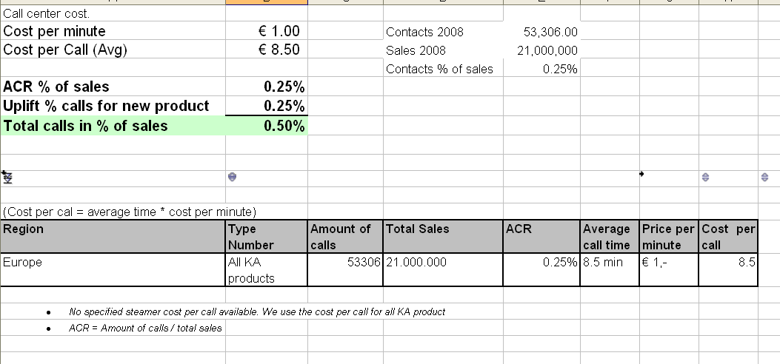

4.2.2 Call center training

CMM and ARC train the call center on location. (Barcelona, Eindhoven, Kingston)

4.2.3 A product specialist (feedback loop)

A product specialist will be installed for the first 6 months after launch. Bi weekly meeting with Consumer care, CMM, ARC, call center Barcelona, Eindhoven, Kingston to discuss the topics of the consumer questions.

4.3 CPI (Cost per Intervention)

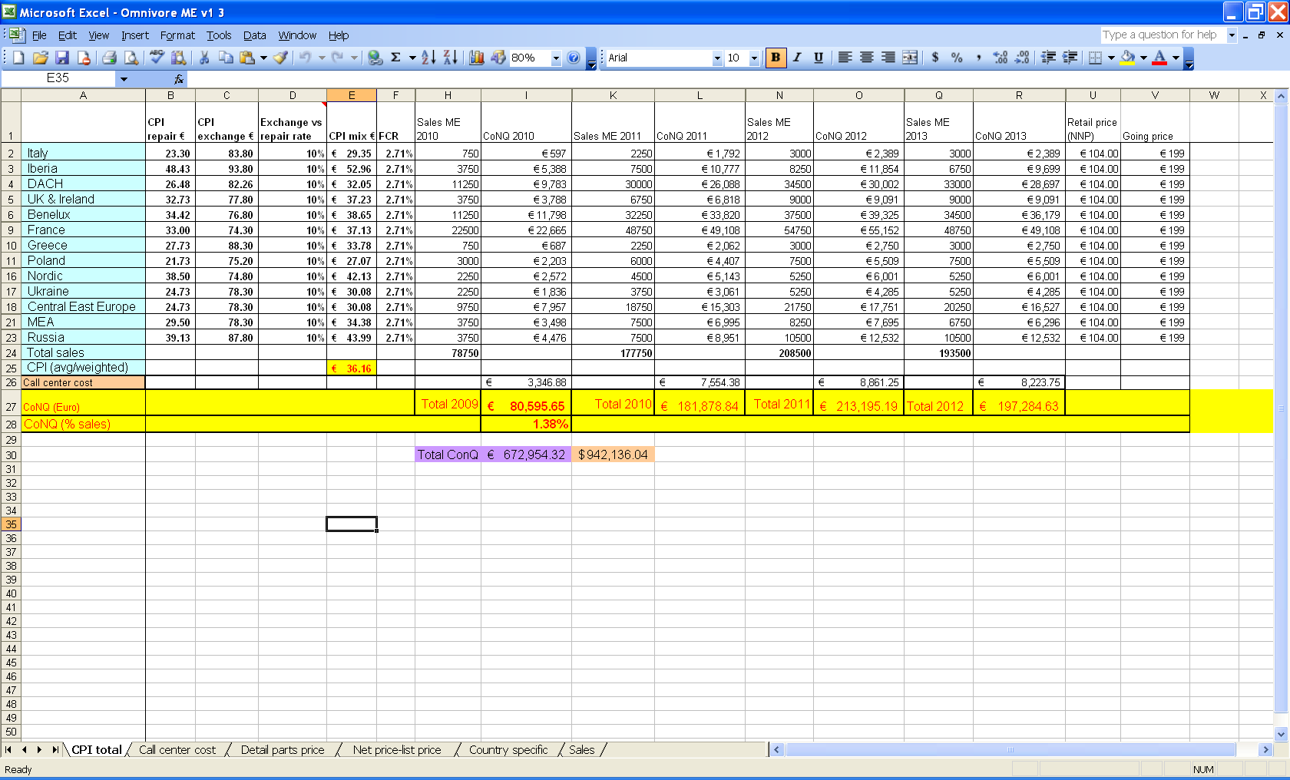

4.4 Predicted Field Quality (PFQ) or Field Call Rate (FCR)
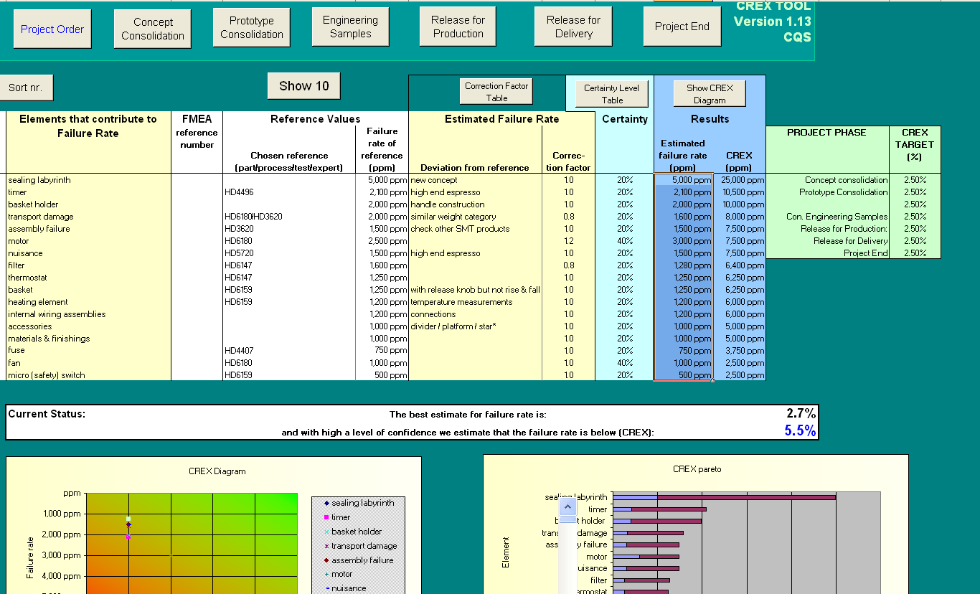

4.5 ConQ (Cost of non Quality)

4.6 Loyalty & registration

Loyalty & registration (free of charge relevant accessory)
Not know what kind of accessories will use for this action.

5 Consumer care package planning

5.1 Consumer care package (Benelux, France, UK)
 |  | Deadline | Accountable | Responsible | Remark
In-box
 | User Manual | Wk1027 | ARC | CMM
 | Quick Start Guide | Wk1027 | ARC | CMM
 | Consumer Care Leaflet | Wk1027 | DFU | CMM
 | Loyalty / registration | Wk1027 | CMM | CMM | General welcome card
 | 30 days try out period | Wk1027 | CMM | CMM
Web
 | Leaflet and Photo's | Wk1027 | DFU/ARC | CMM
 | FAQ's | Wk1027 | ARC | CMM
 | Tips and Tricks | Wk1027 | CMM / Marcom | CMM
 | Instruction movies (tutorials) | Wk1033 | Marcom | CMM | (Movie about how to clean the appliance)
 | Warranty (guarantee leaflet) | Wk1027 | DFU | CMM
Call Center
 | Callcenter training document | Wk1029 | CCQ/ARC | CMM | Tip & Tricks, FAQ’s, Pre sales, Use of the Applinace, service policy, service instruction, Clean ability, consumer registration, 30 days try out period, benefits of the omnivore,Competitors
 | Training execution | Wk1030 | CCQ / ARC / CMM | CCQ / ARC / CMM | Training take place on call center location
 | Product samples | Wk1023 | Project leader | CMM | 6 Samples are add to product list  +2 extra samples for Call Center Barcalona.
 | Product specialist | Wk1030 | CCQ | CMM | Jan Prinsen is contact person for the product specialist
 | Feedback loop plan | Wk1027 | CCQ | CMM | Arrange by weekly call between Philips and call centers
Repair & Exchange
 | Service Manual | Wk1027 | CCQ | CCQ
 | Service Bill of Material, incl. spare parts Purchasing Master data | Wk1029 | CCQ | CCQ
 | Training package repair | Wk1035 | CCQ | CCQ
After Sales
 | Clean ability | Wk1027 | ARC | ARC | Clean ability team (ARC, DQD, CCQ)

5.2 Special phone number
For Europe; 800-number will be added to user manual and quick start guide

5.3 FAQ (Frequently Asked Questions)
FAQ will be translated in to following languages.

5.4 Call center samples

Samples call center
Total samples 14 samples
2 samples in week 1023 (Remco Linnewiel)
8 samples after launch (Michiel Kerkheart)

Europe
2 Kinston UK :UK, Nordic
2 Warshow, poland :East Europe
2 Moskow, Russia :Russia
2 Wittenberg, Germany :Dach
2 Eindhoven, Netherlands :Benelux
4 Barcelona, Spain :Iberia, France, Italy, Greece

Mea
2 Local

Attachment 1: Explanation abbreviations

VPD: Value Proposition Debriefing
AA: Assignment Agreed
PPC: Project Plan Committed
CC: Concept Consolidation
PC: Prototype Consolidation
PV: Product Validated
IR: Industrial Release
CR: Commercial Release
PE: Project end

FSP: Factory Standard Price
IIP: Internal Invoice Price (FSP + NSO kost)

DFU: Direction For Use
FAQ: Frequently Ask Questions
PFQ: Predicted Field Quality
CSO: Consumer Service Offering
ConQ: Cost of non Quality
CSP: Critical Spare Part
CRP: Consumer Replaceable Part

ACR: Average contact Rate
FCR: Field Call Rate
FAQ: Frequently Ask Questions.

LATAM = Latin America
Nafta = North America, Canada and Mexico
APMEA = Asian Pacific, Middle East, Africa
Europe = Europe

