
Consumer Lifestyle

Consumer Care Book
Zephyr

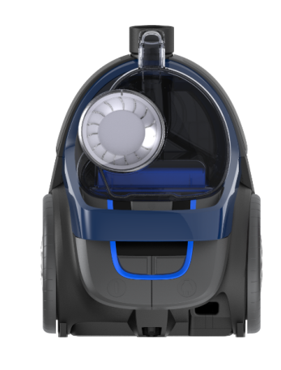

Consumer Marketing Manager

To be approved via PPIM

Approval

Author: | Niels Goedvolk / Yvonne Dingsté
Date: | November 6, 2017
AKB: | AKB 880F-170134
Category: | DA-Floorcare
Status: | Final
Version: | PPC
AKB-number generator

Product introduction
Mid-end bagless, optimized for performance (A+ACA/400W SP with 2000W max input power and 1600W IEC) and hygienic dust disposal, building on new PowerPro Compact design, yet differentiating via additional usability features: soft bumper to protect furniture, 2nd handle and power control

VPH
See PPIM

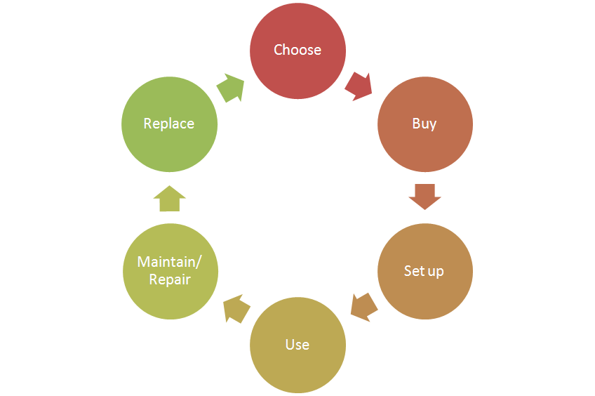
Consumer care focus:
For this product we carry out the standard consumer care package +
- Choose:
- Buy:
- Setup:
- Use:
- Maintain/repair: correct filter cleaning instructions
- Replace: filter packs and accessories correctly available via retailer + online shop

CRM strategy:
N/A
Maybe local activation / registration actions. Not specific at this moment.

Sales introduction and IPD milestone planning

See Business Case in PPIM


IR
AA
PPC
PV
CR
PE
VPD
IR
PC
Project Plan Committed PPC: WK1746
Serviceable parts identified.
Product Validated PV: WK1834
Input: supplier factory codes and price for all Spare Parts.
Input: Exploded view / 3D cad file + BoM list.
Industrial Release IR: WK1838
Reserve capacity (50-100 pcs) of all identified spare parts.
Commercial Release CR: WK1842

Warranty and service policy

- 2 Year warranty
- Repair by component swap.

Proposed Accessories & Consumer Replaceable Parts

Accessories / CRP’s | Commercial Accessory | Online shop price
Filterset for Zephyr FCxxxx | X | € XXXX
Handgrip assy
2 pc. Telescopic Tube
MP nozzle
Crevice Tool
Tubeclip
Long Reach Tool
Connector Active lock
Turbo Brush
Alma nozzle
TriActive LC nozzle

CoNQ prediction & cost driver assumption

See business case in PPIM

Riskmatrix
Risk area | y/n
Known supplier | Y
Product new to Philips / Market / World | n / n / n
All identified risks addressed to project team? | Y

Consumer care package
Item | Detail | Availability timing | Owner | Cost (T.I.C) / Marcom budget
In-box
 | User Manual | PV (text)  IR (final) | Vahan Degoyan
 | World Wide Guarantee Card | IR | Vahan Degoyan
Web
 | Leaflet and Photo's | CR | Vahan Degoyan
 | Specifications in leaflet covered (size, dimensions, weight etc.) (PFS) | CR | Vahan Degoyan
 | Accessory information linked to CTN’s / online (PFS) | CR | Yvonne Dingsté
 | Support movies | CR | N/A
 | Post-purchase FAQ's | CR | Niels Goedvolk
 | Tips & Tricks | CR | Niels Goedvolk
 | Web reviews (trend) | CR | Niels Goedvolk
Call Center
 | Training package - technical and soft skills | IR | Niels Goedvolk
 | Training execution (Powerpoint/online/onsite) | CR | Niels Goedvolk
 | Commercial Product samples | IR | Vahan Degoyan
 | Call center Feedback | CR | Niels Goedvolk
Service Centers
 | Service Manual | CR | Yvonne Dingsté | € 5000,- (approx.)
 | Service Bill of Material, incl. spare parts Purchasing Master data | CR - 2WK | Yvonne Dingsté
 | Training package diagnostics & repair | CR | Yvonne Dingsté

Consumer experience feedback loop
Feedback loop starts after CR for approx. 3-6 months incl. monitoring of calls and R&R trend.

